Objective: In this set of classes the student will “tour” Windows XP (also (Win20000 Control Panel (CP). Side trips to “My Computer” Properties will be conducted based on class questions. Any My Computer Properties / CP System items that we do not cover will be addressed in a future class.

We will be commenting on the important Control Panel options. The screens are somewhat self-explanatory and MS provides help. I will be providing some notes on the more obscure items and my recommendations on settings you may wish to consider.
I do not plan to provide a detail step-by-step text on how to use and configure Windows XP. There are many books on this subject that you can buy.
Note: We’ll be introducing and defining various acronyms. You may wish to create a glossary.

Microsoft provides a very good Control Panel Help – Try it out / Use it.

Lets Start:

- Open Control panel: >START>Control Panel
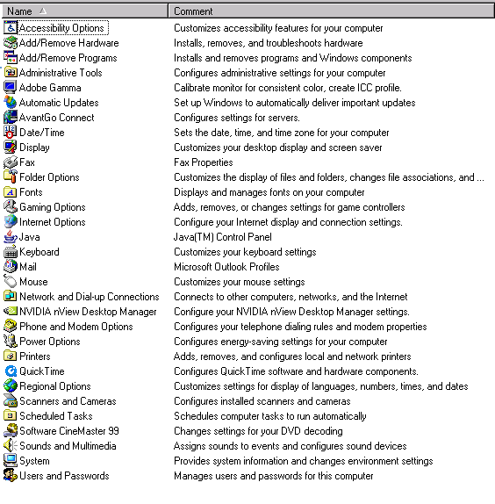
To be consistent with the class: Choose Classic View in the left panel of CP
This is my Control panel from my Win 2000 system. Yours will be similar. The differences will depend on the installed software.

- >Double Click on Accessibility Options to access XP features to help the user relate to the XP graphical user interface (GUI). 5 tabs are displayed.
Read the Windows, Try them out, Use Help to see what they do. Bring questions to the next class.-
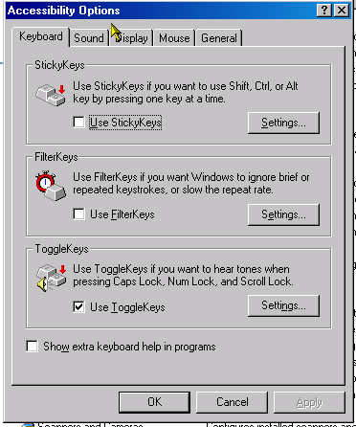
  - Keyboard
    - Options
      - StickeyKeys
      - FilterKeys
      - ToggleKeys
    - On this screen I like ToggleKeys selected (check the check box) to instruct the PC to beep when I accidentally hit Caps Lock, Scroll Lock, or Num Lock.
  - Sound
    - Sound Sentry flashes the screen so that people with hearing problems get a visual clue that the system has issued an alert.
  - Display – Use High Contrast to change the screen so that visually impaired people can read the screen better.
  - Mouse – Allows people with hand eye coordination problems or they may be missing a hand, to navigate in windows without needing the mouse.
  - General –
- Add/Remove Hardwear
- Add/Remove Programs
  - 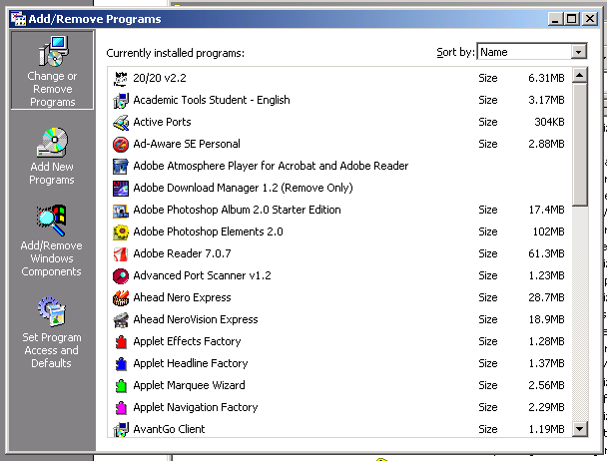
- Administrative Tools
  - 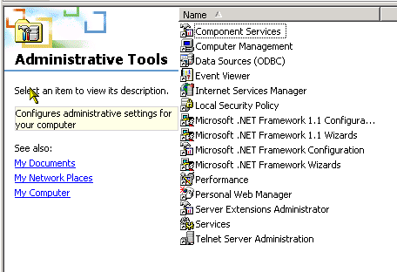
- Adobe Gamma – Adjusts color and white balance on the screen so that pictures display more a natural color balance.
- Automatic Updates – Explore the window. Strongly recommend that Broadband users set the update to daily at an off hour. Dial up users Windows XP should contact Microsoft behind the scenes and download the updates. See http://www.updatexp.com/windows-automatic-updates.html for more information on Windows XP Update.
- Fax – This screen sets up your PC to send and receive FAXs. Sending & receiving a Fax is very easy.
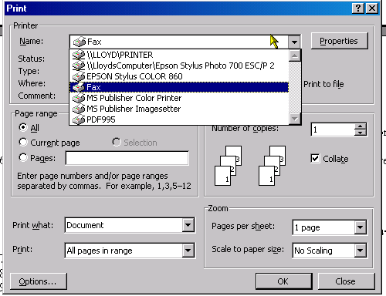
  - To send a fax,
    - Enter the configuration information
    - Plug your phone line into your modem
    - In Word or what ever software you are using, PRINT to your “Fax printer”
When you click OK a wizard will open to guide the sending process. Just follow the screens.
  - To Receive a Fax: (The following is copied from Windows 2000 Help)
    - Open Fax in Control Panel.
    - On the Status Monitor tab, select the Enable manual answer for the first device check box.
    - When an incoming call comes through, the Answer call? prompt appears. If it is a voice call, click No, or if you hear a fax tone, click Yes.
    - Notes
      - You must be logged on as an administrator or a member of the Administrators group in order to complete this procedure. If your computer is connected to a network, network policy settings may also prevent you from completing this procedure.
      - To open Fax, click Start, point to Settings, click Control Panel, and then double-click Fax. If Fax does not appear, you need to install a fax device (such as a modem).
      - Manually answered calls must be monitored when the fax phone rings. This option is useful if you have a fax device sharing a voice line.
      - Related Topics
- Folder Options: Used to control the way Windows Explorer and other programs displays folders. Options are typically matters of personal choice. Options that I like are
  - General
    - Active Desktop – Turn on the Active Desktop feature. The Active Desktop enables you to add Web content to your desktop. You can display pieces of your favorite Web sites directly on your desktop and keep them up-to-date automatically. For example, you could add a stock ticker or news summary page from the Web. Step-by-step procedure

    - Web View – Enable Web Content
      - To add Web content to your desktop
      - Right-click a blank area on the desktop, and then point to Active Desktop.
      - Click New Desktop Item.
      - Follow the instructions on your screen.
      - Notes
        - Before attempting to add Web content to your desktop, make sure the Enable Web content on my desktop option is selected in the Folder Options dialog box. For more information, see Related Topics.
        - If you want to browse the Windows Media Showcase for a desktop component to add, click Visit Gallery.
        - If you want to select some other Web site, type the address of the Web site you want, or click Browse to locate it.
        - Related Topics
    - Browse Folder – Open each in same window (reduces clutter)
    - Double click to open item (Keeps me from opening a lot of stuff when I happen to hit a mouse key)
  - View – I turn on all of the options that will provide me with more complete information. I continue to keep “Hide protected operating system files” selected so that I cannot easily make the mistake of deleting or renamiong an operating system file.
  - File Types – These are the file extension associations to the default program that will process the file when you double click on it.
  - Offline Files: Allows you to continue to work with network files and programs even when you are not connected to the network.
    - MORE TO COME LATER
- Fonts
- Gaming Options
- Internet Options
  - 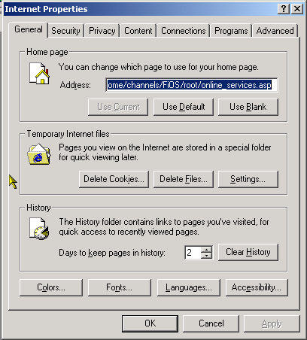
- JAVA
- Keyboard
- Mail
- Mouse
- Network and Dial-Up Connections
- Phone & Modem Options
- Power Options
- Printers
- Scheduled Tasks
- Sounds & multimedia
- System
- Users & Passwords

